**COSC 352.001 – Organization of Programming Languages**

**Fall / 2017**

**Project 3**

**Name: Jose Dixon**

**Instructor: Vojislav Stojkovic**

**Points:**

**Part II. Description of Text/Problem**

# Problem

Write a NetLogo program to:

**(a) 10 points**

Set up initial environment.

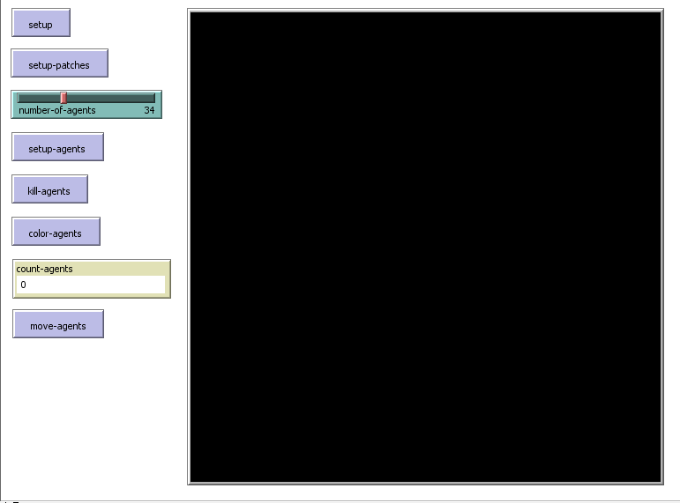

**(b) 20 points**

Set up patches in four colors.

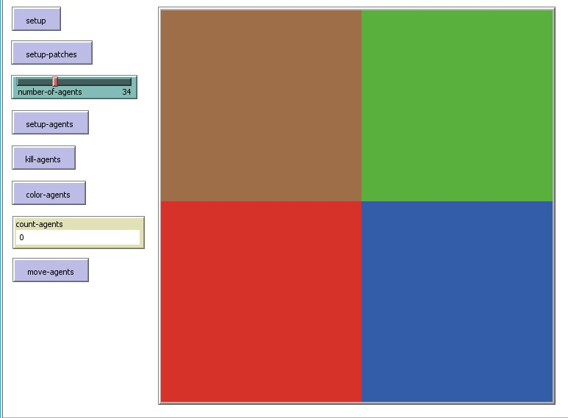

**(c) 10 points**

Set up agents.

Number of agents is defined by slider.

Positions of agents are random.

Shape of agents is circle.

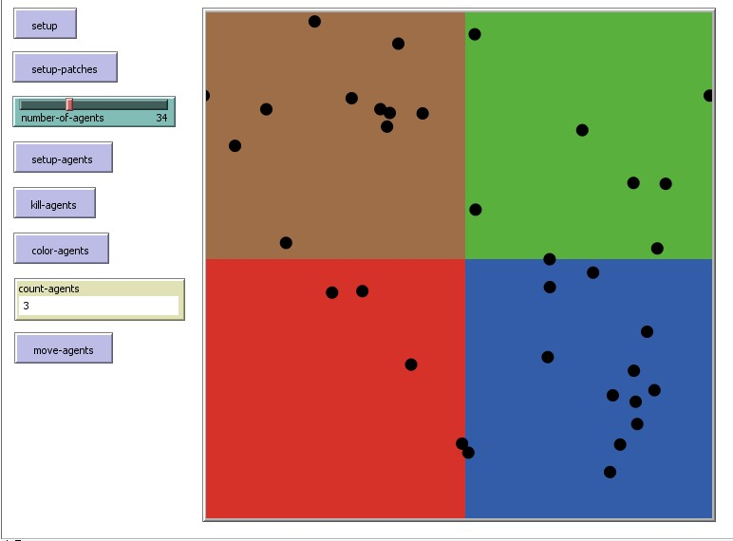

**(d) 15 points**

Kill agents in the first quadrant.

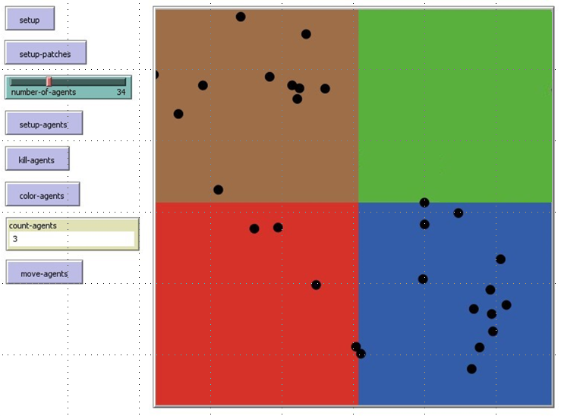

**(e) 15 points**

Color agents in the second quadrant in white.

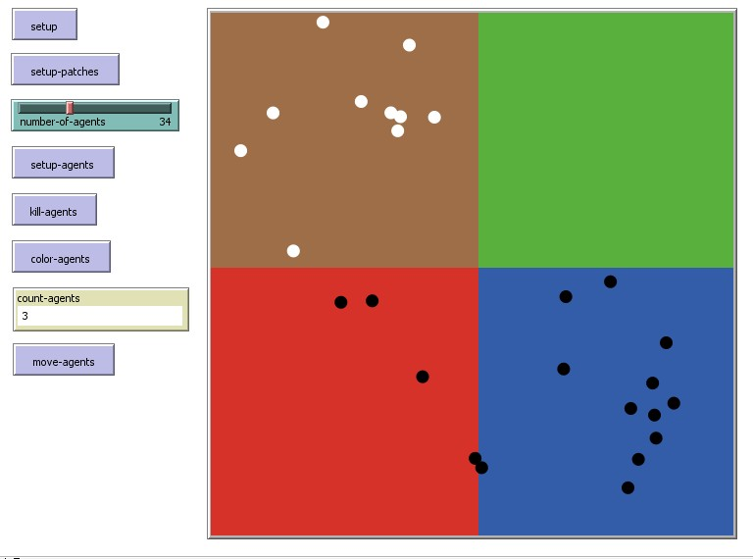

**(f) 15 points**

Count agents in the third quadrant

**4**

**(g) 15 points**

Move agents from the fourth quadrant into the first quadrant.

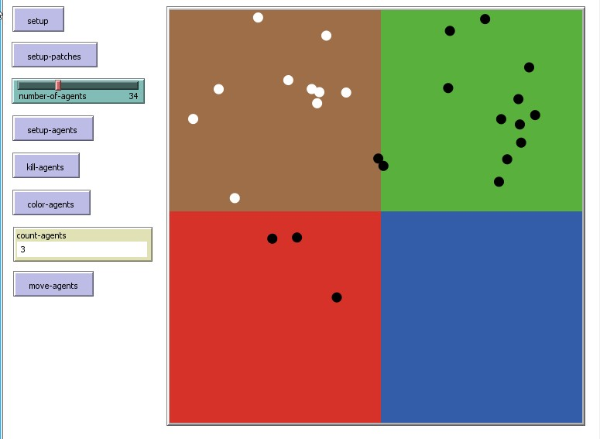

**Part III. Algorithms/Data Structures and Explanations**

* You have four global variables specified for the four quadrants.
* The program starts with setup that clears everything.
* Setup set each quadrant into a patch with its own color by using random-pxcor and pycor keywords.
* Setup agents uses circle turtles that are black and randomly located in the program.
* Kill agents determines if the patch is green it would delete any agents in the green patch using die keyword.
* Color agents determines if the patch is orange to change any agents from black to white.
* Count agents counts the agents in the third quadrant if they are contained in the blue patch.
* Move agents moves any agents if the patch color is red from the fourth quadrant to the green quadrant.

**Part IV. Source Code**

globals [ fiq seq thq foq ]

to setup

clear-all

reset-ticks

end

to setup-patches

clear-all

set fiq patches with [pxcor > 0.5 and pycor >= 0]

ask fiq [set pcolor green] ; Left-up hand corner

set seq patches with [pxcor < 0.5 and pycor > -1]

ask seq [set pcolor orange] ; Right-up hand corner

set thq patches with [pxcor <= 0.5 and pycor < 0]

ask thq [set pcolor blue] ; Left bottom hand corner

set foq patches with [pxcor > 0.5 and pycor < 0]

ask foq [set pcolor red ] ; Right bottom hand corner

end

to setup-agents

set-default-shape turtles "circle"

create-turtles number-of-agents [

set color black

setxy random-pxcor random-pycor ]

if any? turtles [stop]

end

to kill-agents

ask turtles [if pcolor = green [die]]

if not any? turtles [stop]

end

to color-agents

ask turtles [if pcolor = orange [set color white]]

if not any? turtles [stop]

end

to move-agents

ask turtles [if pcolor = red [move-to one-of patches with [pcolor = green] ]]

if not any? turtles [stop]

end

Part V . Test Examples

